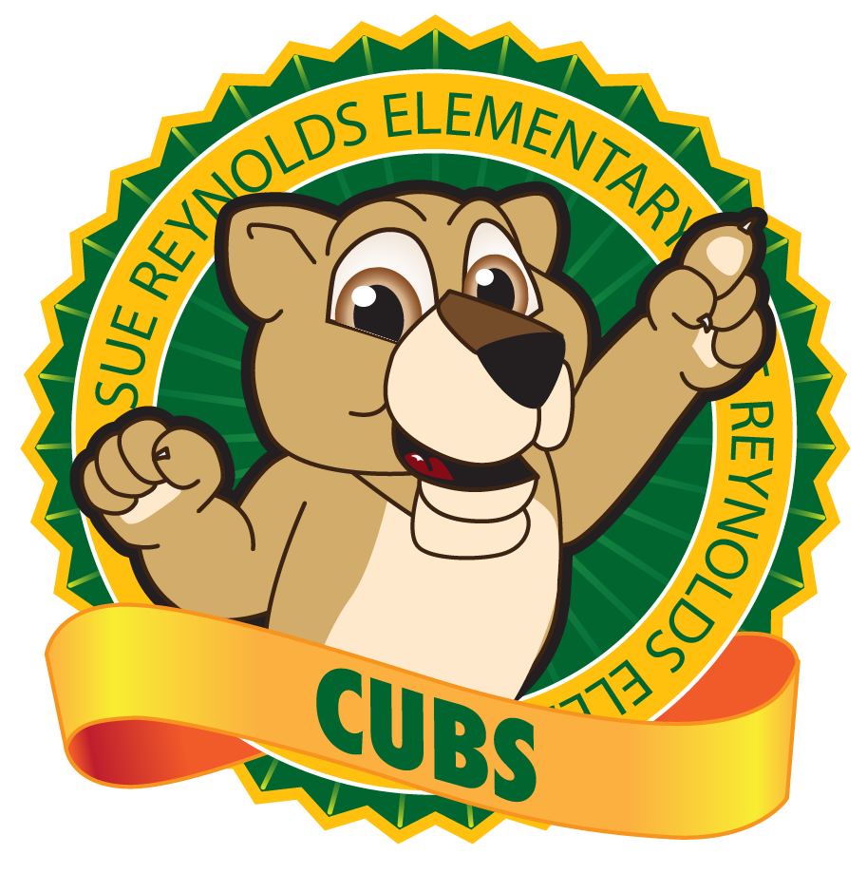

***School- Parent Compact***

***2024-2025***

***Revised: May 30, 2024***

*Sue Reynolds Elementary*

*3840 Wrightsboro Road*

*Augusta, GA 30909*

*706-855-2540*

<http://reynolds.rcboe.org/>

*Mrs. Donna Culbreath, Principal*

***Activities to Build Partnership***

Reynolds promotes parental engagement through various events and programs such as:

* Training & Volunteering
* Family Workshops
* Math Night
* Literacy Night
* Conferences

***Communication about Student Learning***

Reynolds maintains communication with parents through:

* Flyers
* Remind 101
* Class Dojo
* Teams
* School Marquee/Shout Points
* Phone Calls
* Text Messages
* Website
* Facebook
* Instagram
* Twitter

***What is a School-Parent Compact?***

It is a written agreement describing how all members of a school community (parents, teachers, principals, and students) agree to share responsibility for student learning. This compact helps build a bridge between the school and home to encourage learning, communication, and achievement for all students.

**What is Title I?**

The purpose of Title I is to ensure that all children have a fair, equal and significant opportunity to obtain a high-quality education. Title I provides technical assistance, resources, and program monitoring of the Richmond County School System’s Title I schools to ensure that all children have an opportunity to obtain a high-quality education and to achieve proficiency on high academic standards.

***Jointly Developed***

Parents, students, and staff partnered together to develop this school-parent compact for achievement. Parents are encouraged to attend annual revision meetings held in the spring each year to review the compact and make suggestions based on student needs and school improvement needs. Parents are also encouraged to participate in the annual Title I parent survey that is also used as a tool to collect parent feedback regarding current Title I programs and policies.

***School: What Teachers Will Do at School***

Sue Reynolds Elementary School will work with students and their families to support students’ success in reading and math. Some of our key connections with families will be:

»**Math:** We will provide students with Number Talks lessons daily in math instruction. As well as daily fluency stations will be utilized in all classrooms. We will teach daily with manipulatives delivering a differentiated approach to learning for our student. We will utilize GaDoe learning plans in the classrooms.

»**Reading:** Teachers will utilize AR daily to increase comprehension, i-Ready, Lexile scores, Fundations, and Savvas Reading Curriculum to deliver balanced targeted instruction focusing on comprehension, vocabulary, and fluency.

***Students: What Students Will Do***

Sue Reynolds Elementary School students joined staff and parents to develop ideas about how they can succeed in school and reach for the stars in math and reading. Students thought of the following ideas to make connections between learning at home and school:

» **Math:** Each night, I will practice math fluency by using First in Math. I will also use my Mental Math strategies from Number Talks.

» **Reading**: I will spend 20 minutes each night reading from MyOn’s recommenced reading list or a book that is at my level (spans from 100L below to 50L above my Lexile measure).

***Home: What Families Will Do at Home***

Sue Reynolds Elementary School parents joined staff to develop ideas about how families can support students’ success in reading and math.

»**Math:** I will have my child to practice grade level math strategies using Number Talks lessons and use Mental Math strategies from Number Talks every day. I will have my child work on basic +,-, x, and / facts.

»**Reading:** I will log my child onto MyOn and i-ready reading daily and have them read from their recommended reading list or read a book that is within their recommended Lexile range (spans from 100L below to 50L above his/her Lexile measure). I will monitor their studying habits.

***Our Goals for Student Achievement***

***District Goals***

During the 2024-2054 school year, we will increase student content mastery in tested subject areas on the Georgia Milestones by 5%.

During the 2024-2025 school year, we will increase post-high school readiness by increasing our graduation rate from 81% to 83%.

During the 2024-2025 school year, we will increase the number of highly effective teachers and leaders retained in RCSS by 3%.

***School Goals***

 By May of 2025, Sue Reynolds Elementary School will implement evidence-based instructional strategies in reading comprehension to increase the percentage of students scoring below reading proficiency on the ELA Georgia Milestones from 54.48% to 59.48% (an improvement affecting 29 students).

By May 2025, Sue Reynolds Elementary will implement differentiated instructional strategies in all Math domains to increase the percentage of on-grade-level learners from 27% to 30%, achieving a total of 174 students performing at or above grade level, as measured by Math I-Ready assessments.

By May of 2025, Sue Reynolds Elementary School will increase parent and family engagement by enhancing communication and providing resources and services to support their children's education at home. The goal is to increase the percentage of parents actively engaged in school activities and workshops to 75%.

***Focus Areas***

-Writing, vocabulary development, read for fluency and comprehension

-Number sense, fact fluency, multi-step problem solving

***Teachers, Parents, and Students—Together for Success***